 |  | 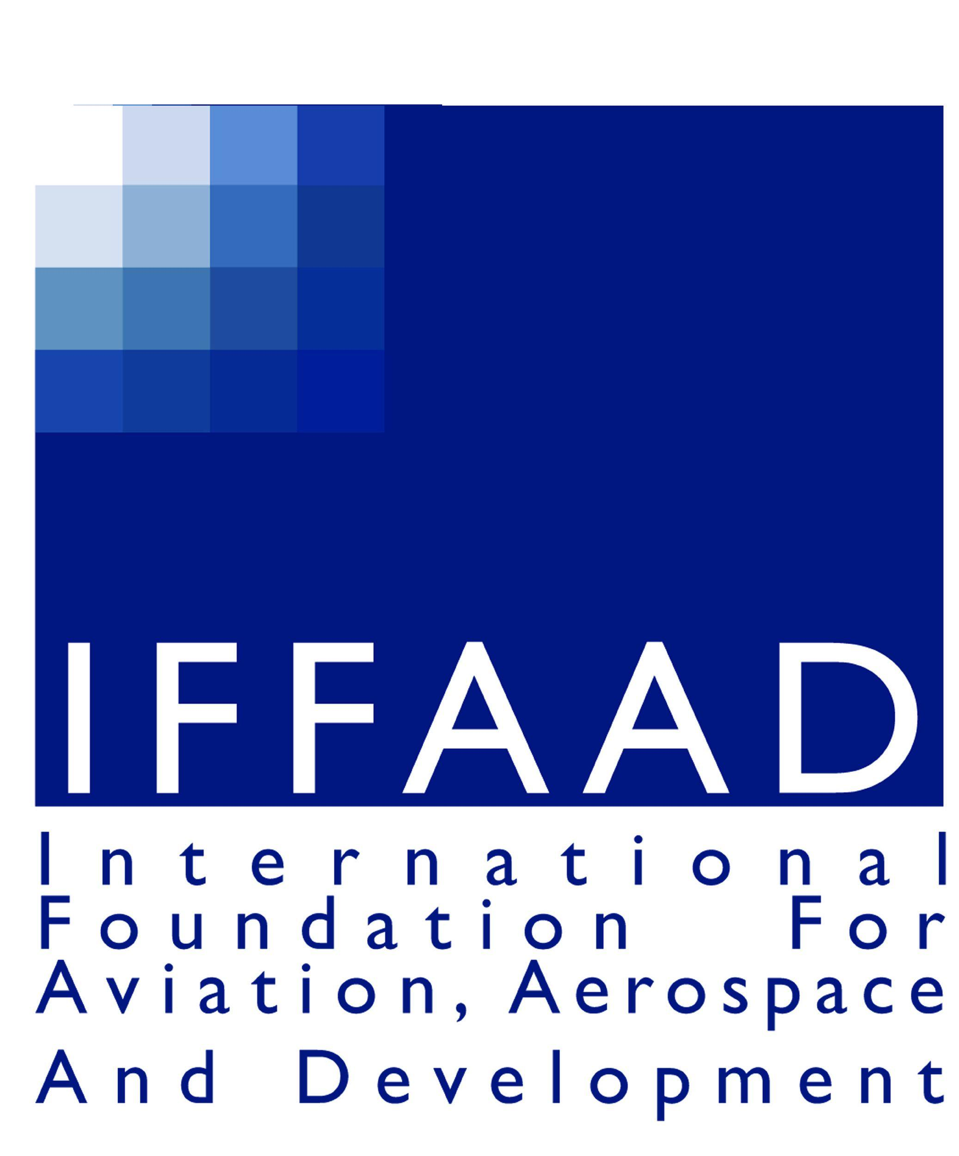
THIRD WORKSHOP & INTERNATIONAL CONFERENCE ON LAW & REGULATION OF AIR TRANSPORT

Dated: 19.10.2011

REF: THIRD WORKSHOP & INTERNATIONAL CONFERENCE ON LAW & REGULATION OF AIR TRANSPORT AND SPACE APPLICATIONS TO BE HELD AT THE NATIONAL LAW UNIVERSITY, SECTOR – 14, DWARKA, NEW DELHI 110078, INDIA

SUBJECT: ANNOUNCEMENT OF NEW DATES

Dear all,

As you are aware that the above referred 3rd Workshop & International Conference being co-organized by Institute of Air & Space Law, McGill University, Montreal, Canada, National Law University, Dwarka, New Delhi and International Foundation for Aviation, Aerospace & Development (India Chapter), which was going to be held from 2nd – 6th December, 2011, has been postponed due to the strike of the Administrative Staff at McGill University, the same is regretted.

However, we are pleased to inform you that after consultation between the three Institutions, it has been decided that the 3rd Workshop & International Conference on Law & Regulation of Air Transport and Space Applications will now be held from Wednesday, 25th – Sunday, 29th April, 2012 at the National Law University, Sector – 14, Dwarka, New Delhi 110078, India.

The Workshop will take place from 25th & 26th April, 2012 and the International Conference will be held on 27th, 28th & 29th April, 2012.

We request all those whose abstracts have been selected to kindly prepare their full paper/presentation and submit the same by Friday, 13th January, 2012.

In case you require any further information or clarifications on the foregoing, please do not hesitate to contact us at iffaadindia@hotmail.com. We are also preparing a website (www.aviationlawconference.com) for the conference which will be ready in about ten day’s time.

Best wishes

Sanat Kaul Ram Jakhu Srikrishna Deva Rao
Co-Chair Co-Chair Co-Chair

